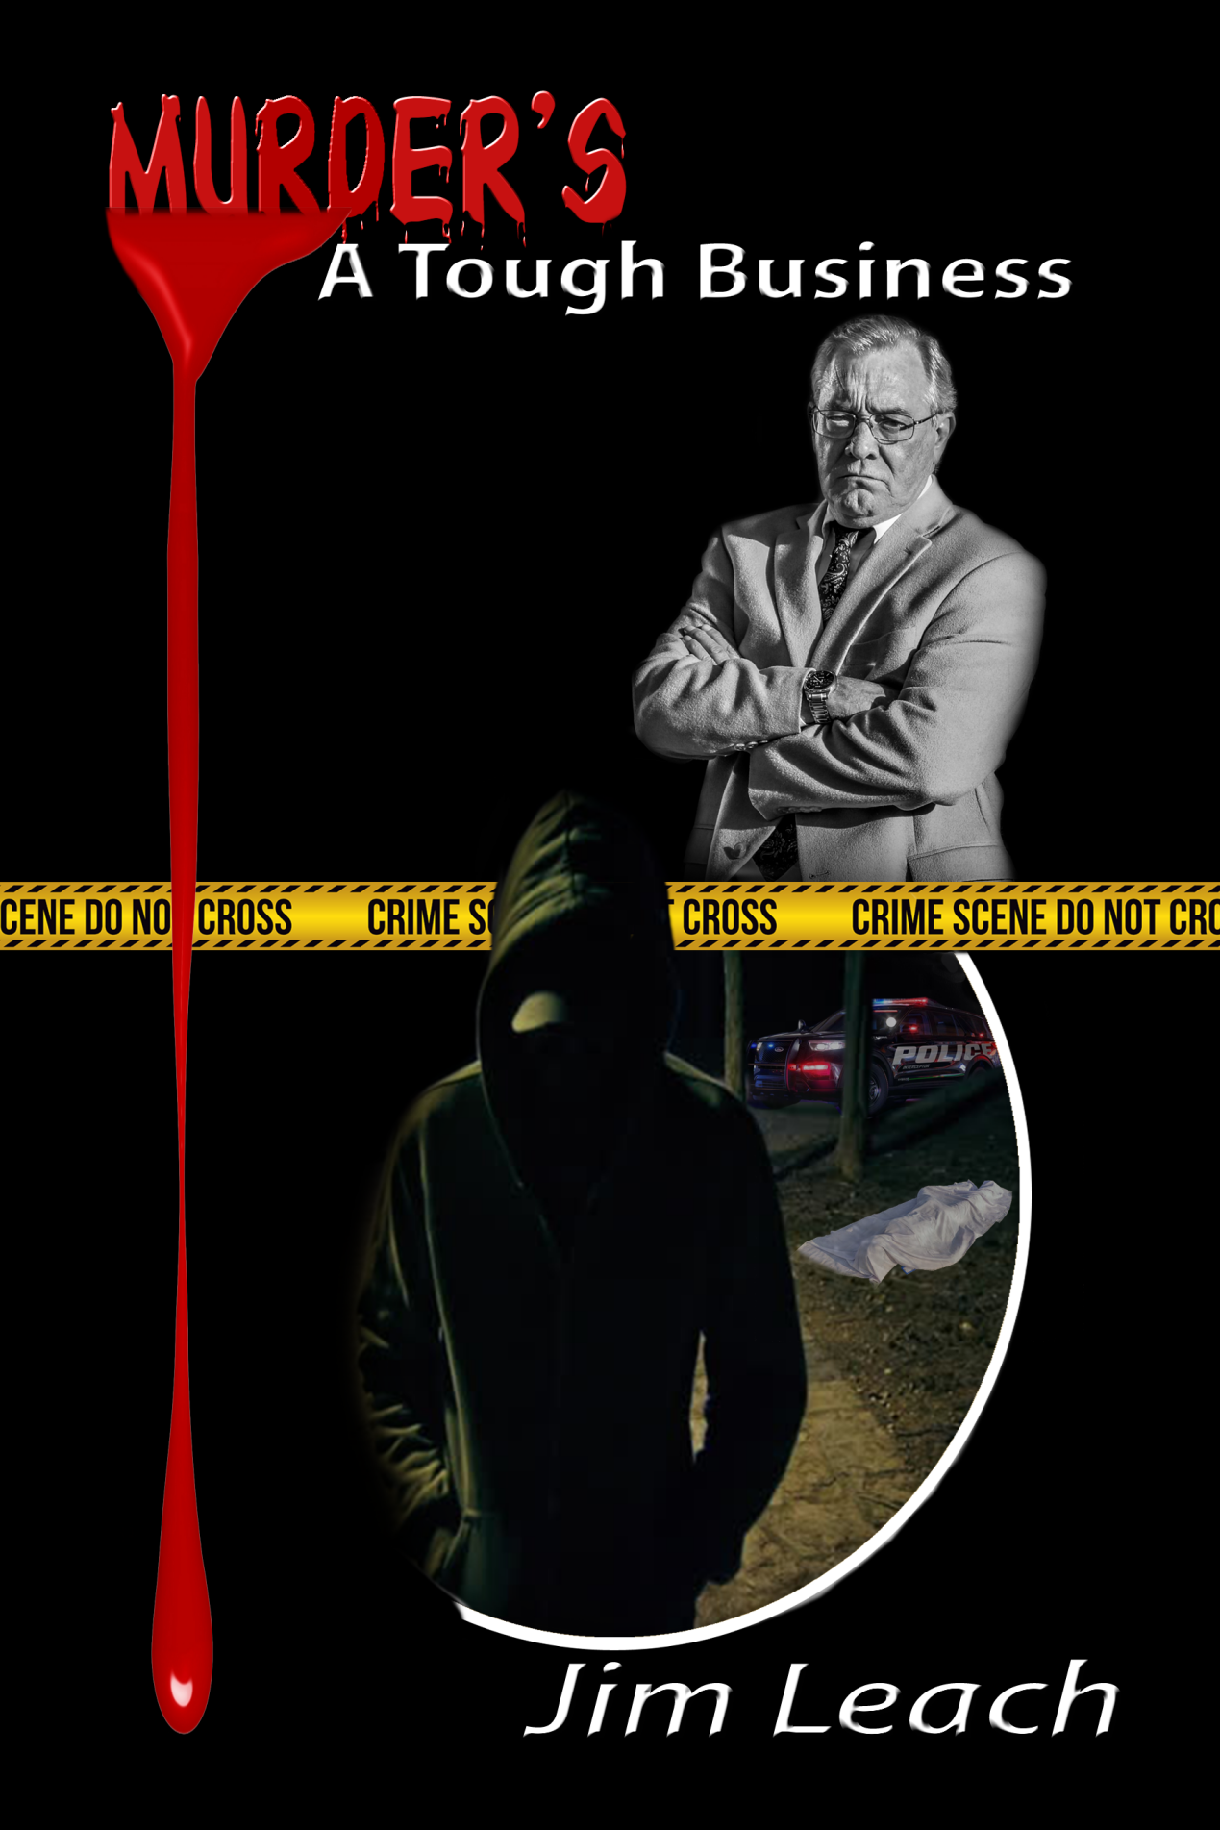
Amazon.com : Murder's A tough Business

Murder has been glamorized in movies, TV, and all types of media. If it bleeds, it leads. This work is NOT a glamorous portrayal of man's greatest sin. It is real life.
The book is full of REAL LIFE cases analyzed by someone who investigated murders for decades. “Murder’s A Tough Business” presents a unique combination of journalistic research and years of hands-on experience to give the reader a true understanding of how the police solve the worst crimes imaginable.
If you want to be a better police officer, or would enjoy having a TRUE understanding of what is happening on your favorite crime drama, this book is a MUST READ!

Jimmie (Jim) Leach

